SEMESTER TWO
Papers written by
Australian Maths Software

YEAR 12, UNIT 3-4

MATHEMATICS APPLICATIONS
REVISION 1
2016

Section Two
(Calculator–assumed)

Name: _________________________________

Teacher: ________________________________

TIME ALLOWED FOR THIS SECTION

Reading time before commencing work: 10 minutes
Working time for section: 100 minutes

MATERIAL REQUIRED / RECOMMENDED FOR THIS SECTION

To be provided by the candidate

Standard items: pens, pencils, pencil sharpener, highlighter, eraser, ruler.

Special items: drawing instruments, templates, notes on up to two unfolded sheet of A4 paper, and up to three calculators approved for use in the WACE examinations.

IMPORTANT NOTE TO CANDIDATES

No other items may be taken into the examination room. It is your responsibility to ensure that you do not have any unauthorised notes or other items of a non–personal nature in the examination room. If you have any unauthorised material with you, hand it to the supervisor before reading any further.

To be provided by the supervisor
Question/answer booklet for Section Two.
Formula sheet retained from Section One.
Structure of this examination

 | Number of questions available | Number of questions to be answered | Working time (minutes) | Marks available | Percentage of exam
Section One  Calculator—free | 7 | 7 | 50 | 50 | 35
Section Two  Calculator—assumed | 8 | 8 | 100 | 100 | 65
Total marks |  |  |  | 150

Instructions to candidates

1. The rules for the conduct of this examination are detailed in the Information Handbook. Sitting this examination implies that you agree to abide by these rules.

2. Write your answers in the Question/Answer booklet.

3. You must be careful to confine your responses to the specific questions asked and to
follow any instructions that are specific to a particular question.

4. Spare pages are provided at the end of this booklet. If you need to use them, indicate
in the original answer space where the answer is continued i.e. give the page number.

5. Show all your working clearly. Your working should be in sufficient detail to allow your answers to be checked readily and for marks to be awarded for reasoning. Incorrect answers given without supporting reasoning cannot be allocated any marks. For any question or part question worth more than two marks, valid working or justification is required to receive full marks. If you repeat an answer to any question, ensure that you cancel the answer you do not wish to have marked.

6. It is recommended that you do not use pencil, except in diagrams.

7. The Formula Sheet is not to be handed in with your Question/Answer booklet.

8. (7 marks)

Ben conjectured that many of the Year Ten girls had dyed their hair blonde. He did a survey of 100 randomly selected Year Ten students and the results are tabled below.

 | Hair colour
 | Black | Brown | Blonde
Girls | 16 | 7 | 28 | 51
Boys | 14 | 25 | 10 | 49
 | 30 | 32 | 38 | 100

(a) Represent the numbers of each hair colour as percentages for girls and then for boys.
(3)

 | Hair colour
 | Black | Brown | Blonde
Girls
Boys

(b) Analyse the data and make a conclusion about the conjecture above. (4)
9. (25 marks)
The number of people attending the cinema are listed on the table below.

 |  |  | Number attending the cinema
1 | Week 1 | Monday | 30
2 |  | Tuesday | 45
3 |  | Wednesday | 32
4 |  | Thursday | 33
5 |  | Friday | 45
6 |  | Saturday | 50
7 |  | Sunday | 46
8 | Week 2 | Monday | 32
9 |  | Tuesday | 47
10 |  | Wednesday | 33
11 |  | Thursday | 32
12 |  | Friday | 47
13 |  | Saturday | 53
14 |  | Sunday | 48
15 | Week 3 | Monday | 33
16 |  | Tuesday | 48
17 |  | Wednesday | 35
18 |  | Thursday | 34
19 |  | Friday | 50
20 |  | Saturday | 55
21 |  | Sunday | 48
22 | Week 4 | Monday | 35
23 |  | Tuesday | 51
24 |  | Wednesday | 33
25 |  | Thursday | 36
26 |  | Friday | 52
27 |  | Saturday | 54
28 |  | Sunday | 51

The graph of the attendance is shown below:
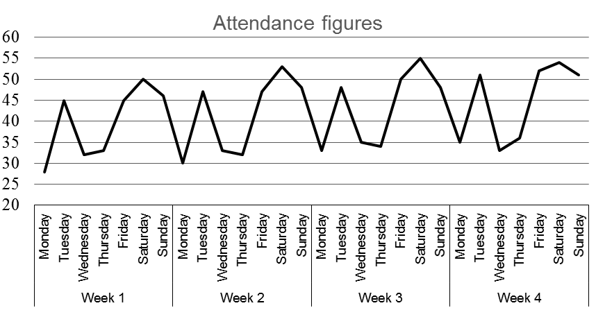

(a) Comment on the trend shown on the graph. (2)

(b) State the length of the cycle and draw a circle about a cycle on the graph above.
(2)

(c) The graph below shows a three point moving average of the data.
Explain why the 3MA is not close to a straight line. (2)
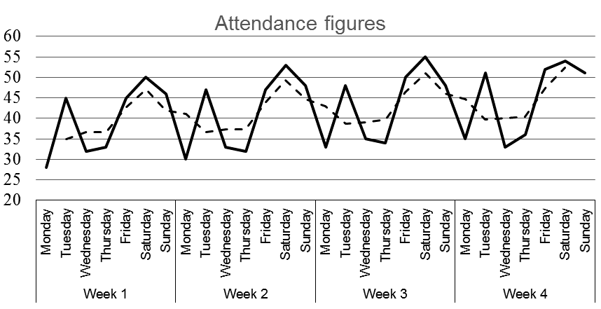

The 7 point moving average has been added to the table below.
 |  |  | Number attending the cinema | 7 MA
1 | Week 1 | Monday | 28
2 |  | Tuesday | 45
3 |  | Wednesday | 32
4 |  | Thursday | 33 | A
5 |  | Friday | 45 | 40
6 |  | Saturday | 50 | 40
7 |  | Sunday | 46 | 41
8 | Week 2 | Monday | 30 | 40
9 |  | Tuesday | 47 | 41
10 |  | Wednesday | 33 | 41
11 |  | Thursday | 32 | 41
12 |  | Friday | 47 | 42
13 |  | Saturday | 53 | 42
14 |  | Sunday | 48 | 42
15 | Week 3 | Monday | 33 | 43
16 |  | Tuesday | 48 | 43
17 |  | Wednesday | 35 | 43
18 |  | Thursday | 34 | 43
19 |  | Friday | 50 | 44
20 |  | Saturday | 55 | B
21 |  | Sunday | 48 | 44
22 | Week 4 | Monday | 35 | 44
23 |  | Tuesday | 51 | 44
24 |  | Wednesday | 33 | 44
25 |  | Thursday | 36 | 45
26 |  | Friday | 52
27 |  | Saturday | 54
28 |  | Sunday | 51

NB 7 MA = Seven point moving average

(d) Determine the values of A and B. (4)

(e) Use the counters in the first column and the moving averages to calculate the
equation of the least-squares line to model the long term trend of the data. (4)

(f) The seasonal indices for Saturday for the four weeks are 1.254, 1.279, 1.271 and
1.212.

(i) Show how the figure 1.254 was calculated for Week 1. (2)

(ii) Calculate the average weekly seasonal index for Saturday. (2)

(g) Use the least-squares line to predict the number attending the cinema on Saturday in
Week 5. (3)

Consider the data below. The percentage of weekly attendances are shown for each day of any given week.

 |  |  | Number attending the cinema | Attendance as % of week’s daily mean
1 | Week 1 | Monday | 28 | 70
2 |  | Tuesday | 45 | 113
3 |  | Wednesday | 32 | 80
4 |  | Thursday | 33 | 83
5 |  | Friday | 45 | 113
6 |  | Saturday | 50 | 125
7 |  | Sunday | 46 | 115
8 | Week 2 | Monday | 30 | 72
9 |  | Tuesday | 47 | 113
10 |  | Wednesday | 33 | 80
11 |  | Thursday | 32 | 77
12 |  | Friday | 47 | 113
13 |  | Saturday | 53 | 128
14 |  | Sunday | 48 | 116
15 | Week 3 | Monday | 33 | 91
16 |  | Tuesday | 48 | 132
17 |  | Wednesday | 35 | 96
18 |  | Thursday | 34 | 93
19 |  | Friday | 50 | 137
20 |  | Saturday | 55 | 151
21 |  | Sunday | 48 | 132
22 | Week 4 | Monday | 35 | 94
23 |  | Tuesday | 51 | 137
24 |  | Wednesday | 33 | 89
25 |  | Thursday | 36 | 97
26 |  | Friday | 52 | 139
27 |  | Saturday | 54 | 145
28 |  | Sunday | 51 | 137

(h) Explain how the 113% is calculated for Tuesday of Week 1. (2)

(i) Use the average percentage method to calculate the seasonal index for the Tuesday
performances. (2)

10. (12 marks)

(a) A council inspector planned to inspect new home building sites with access roads shown on the diagram below.

w.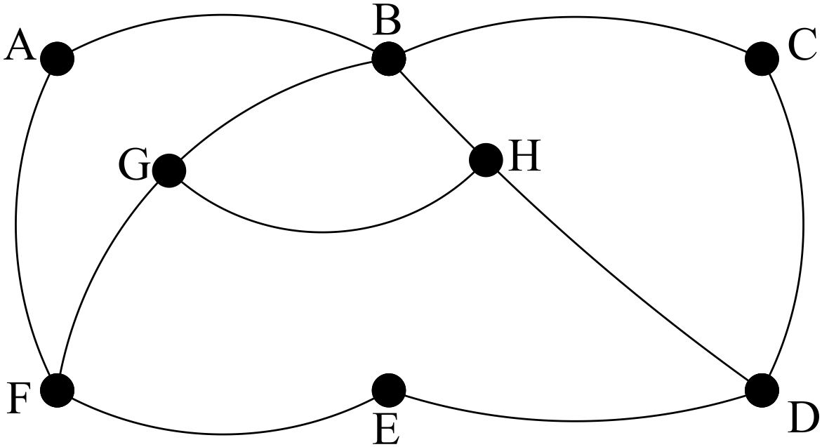
(i) Is it possible to visit each site without going over the same road twice?
Explain. (3)

(ii) Add an arc to the network below so that the following diagram contains a
Hamiltonian cycle. List the cycle and explain why it is Hamiltonian. (3)

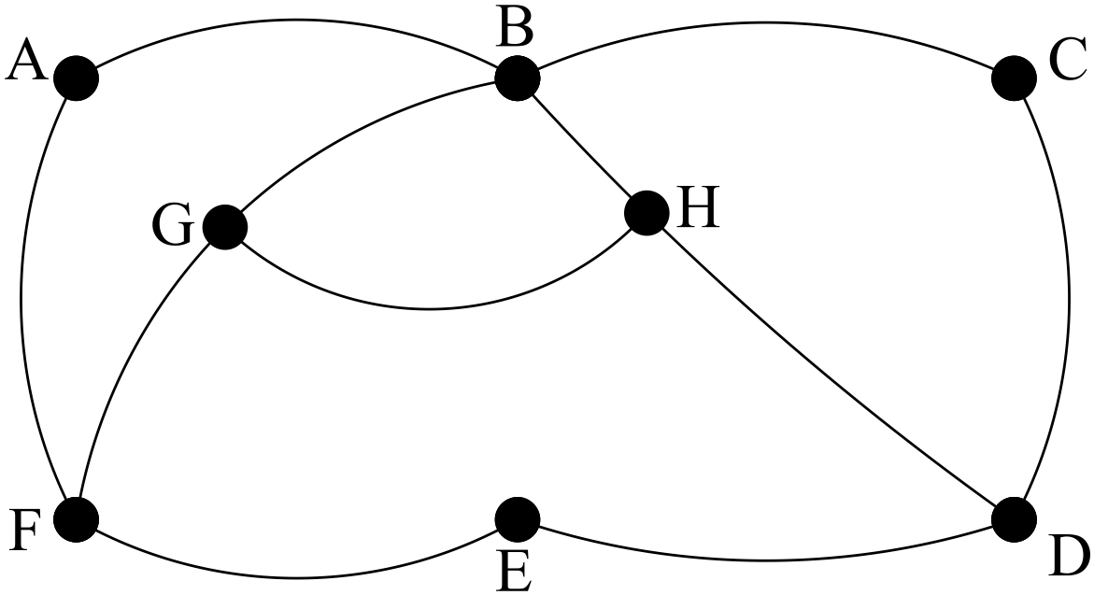
(b) (i) The planar graph below is equivalent to a three dimensional platonic solid.

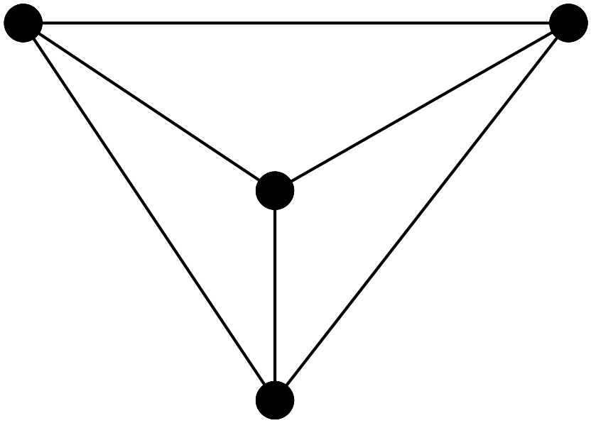
Name the solid and explain why the two are equivalent.
Sketch the platonic solid. (3)

(ii) Show that Euler’s Rule works for the planar graph and for the
platonic solid. (3)

11. (17 marks)
It has been conjectured that the more cigarettes you smoke per day the shorter
your life will become.

A study was done and the results are shown in the table and graph below.
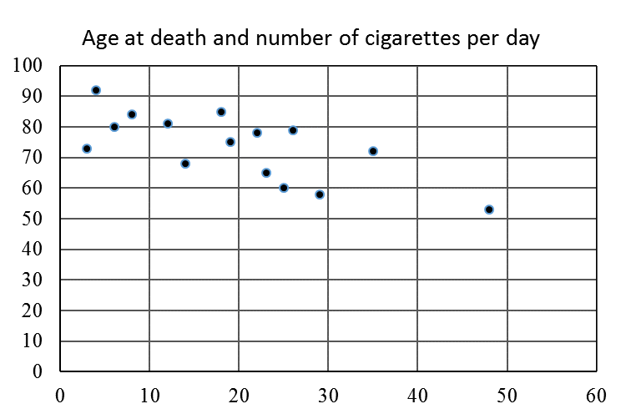
Age at death
Number of cigarettes smoked each day

(a) Identify the response variable and the explanatory variable. (2)

(b) The correlation coefficient between the two variables is -0.706.
Use this value to detemine the coefficient of determination and use it to
determine percentage of unexplained variation. (3)

(c) Suggest another factor that could have influenced the result. (1)
The graph below has the trend line added.
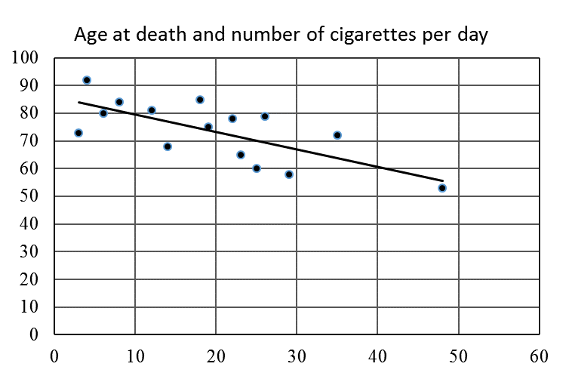
Age at death
Number of cigarettes smoked each day

The equation of the trend line is 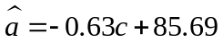.
(d) What does the trend line suggest the age of death is if a person does not smoke?
(2)

(e) Use the trend line to suggest the number of years lost if a person smokes 30
cigarettes a day. (1)

(f) The sign of the correlation coefficient and the slope of the trend line are both
negative. Explain. (2)

(g) Predict the expected life span of a smoker who smokes 60 cigarettes a day and
comment on your result. (2)
(h) The conjecture was “The more cigarettes you smoke per day the shorter your life.”
Write up the results of the study in a systematic and concise manner. (4)

12. (7 marks)
(a) The formula for the effective rate of interest (ERI) is given by 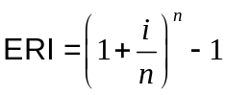
where i is the annual rate of interest and n is the number of compounding periods.
NB If the interest is 8% then i = 0.08

Determine the effective rate of interest when $14 000 is invested at 3.45% per annum
compounded monthly. (2)

(b) Paul invested $10 000 invested at 12% compounded weekly.

Paul’s twin Ian also invested $10 000, but he invested it at 12.5% compounded monthly.

Which man’s investment was worth more at the end of the first year?
Show all working. (5)

13. (16 marks)
(a) Peter has a loan of $1000 on which he pays interest at a rate of 4.5% per annum
calculated daily.
(i) What is the interest at the end of the first month? (3)

Peter pays $100 a month.
(ii) What amount does Peter owe after his first monthly payment? (2)

(iii) What amount does Peter owe after his eighth monthly payment? (3)

(iv) How long does Peter take to pay off his loan? (2)

(v) How much does Peter pay in total? (3)

(vi) Had Peter paid $200 off his loan each month, how much would he have saved?
(3)

14. (9 marks)
(a) Alan bought a laptop computer for $2 000. The computer is expected to be only worth
$200 after three years.

Calculate the annual rate of depreciation of the computer. (4)

(b) Marilyn bought a perpetuity that paid $41 500 a year. Her money was invested
at 8% per annum, compounded monthly.

The formula for a perpetuity is
Payment = Present value x r where r s the annual interest rate.

(i) How much did Marilyn invest? (3)

(ii) Had Marilyn put her money in a shoebox under her bed and just spent $41 500
each year, how long would the money have lasted? (2)


15. (7 marks)
A building company has four blocks that need clearing. Four clearing companies have given
quotes for each of the four blocks as shown in the table below.
Quotes are in thousands of dollars.

 | Companies that clear blocks
Blocks | Smiths | Clear Fast | Tidy Clearing | Quick & Clear
A | 7 | 6 | 4 | 5
B | 6 | 4 | 5 | 6
C | 4 | 5 | 5 | 3
D | 3 | 4 | 3 | 7

(a) Use the Hungarian Algorithm to assign the tasks to the clearing companies that
minimises the total cost of clearing the four blocks. (5)

 | Companies that clear blocks
Blocks | Smiths | Clear Fast | Tidy Clearing | Quick & Clear
A
B
C
D

 | Companies that clear blocks
Blocks | Smiths | Clear Fast | Tidy Clearing | Quick & Clear
A
B
C
D

 | Companies that clear blocks
Blocks | Smiths | Clear Fast | Tidy Clearing | Quick & Clear
A
B
C
D

(b) Present the solution as a bipartite graph. (2)

END OF SECTION TWO

